Week 6 day 1 and 2
Demo notes-concurrent agents
https://codeshare.io/5Dd3Rl
Requirements.txt and execution:
agent-framework-openai>=1.0,<2.0
agent-framework-orchestrations>=1.0,<2.0
python-dotenv>=1.0,<2.0
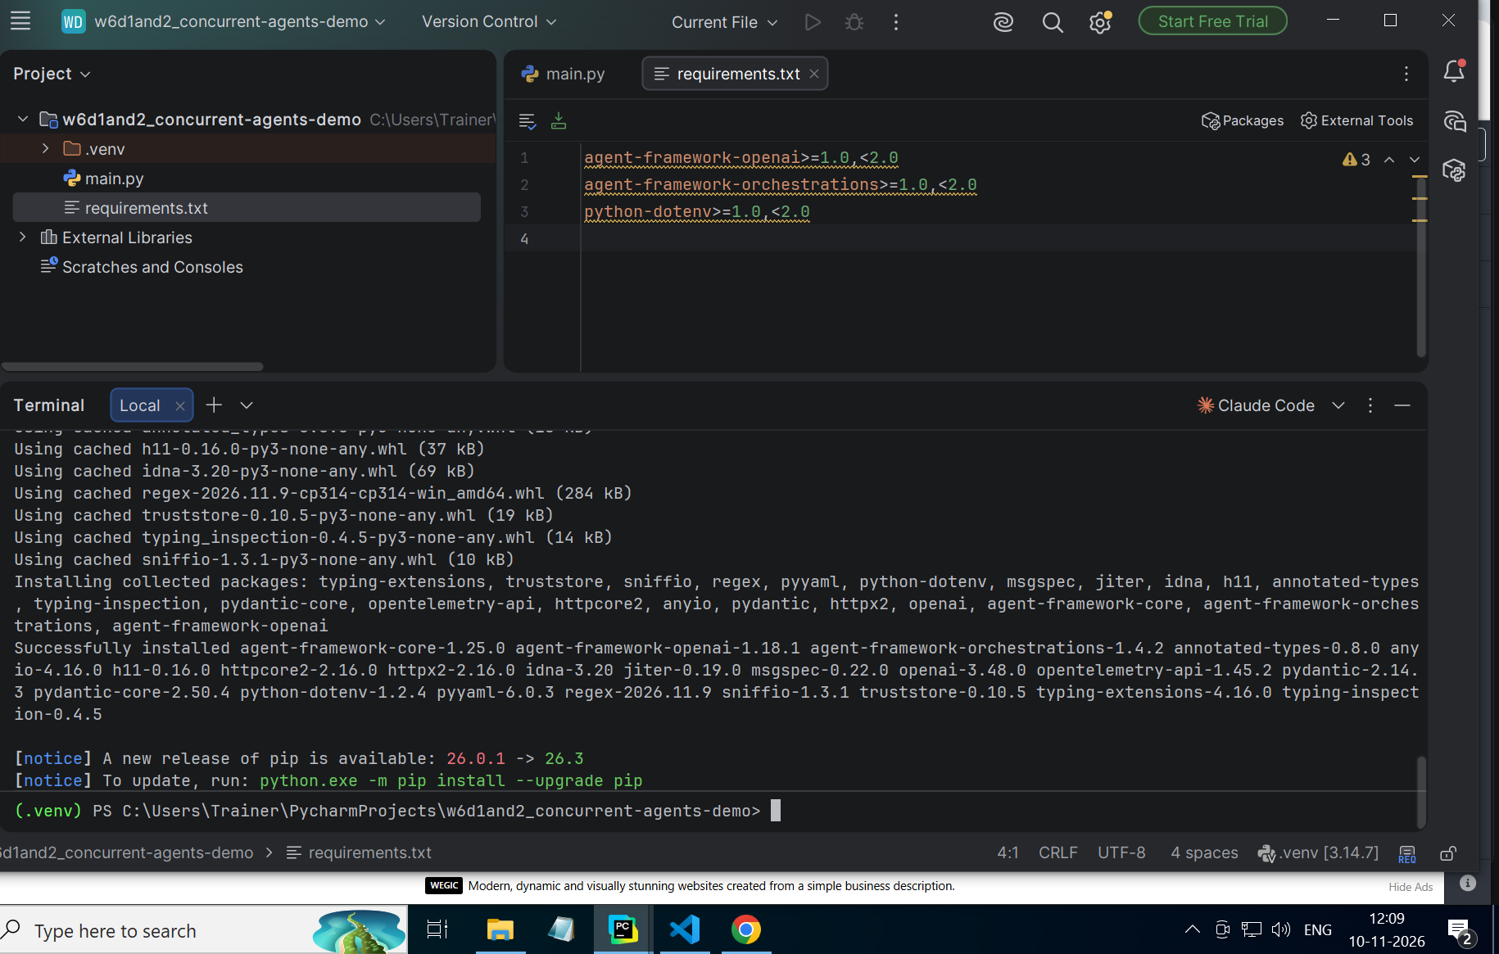
python -m pip install -r requirements.txt
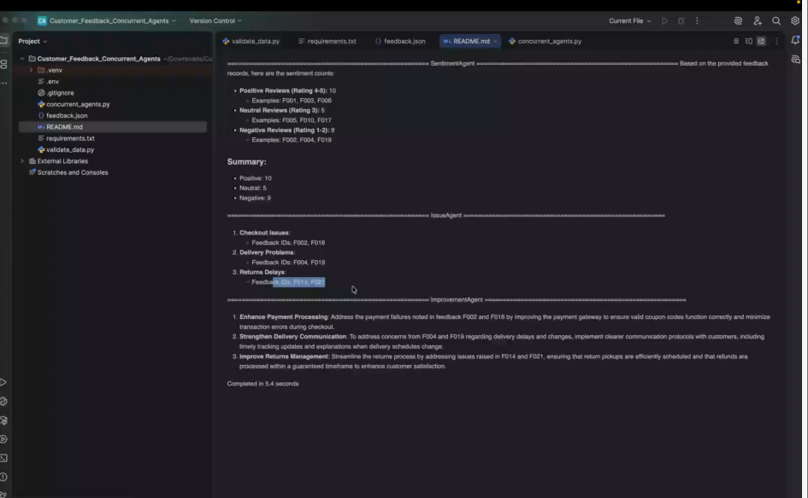
Issues agent-Bunching issues into buckets
Improvements agent
Not required to run after the other
Use concurrent-can run in parallel
If bigger chunk, should’ve run a RAG around it
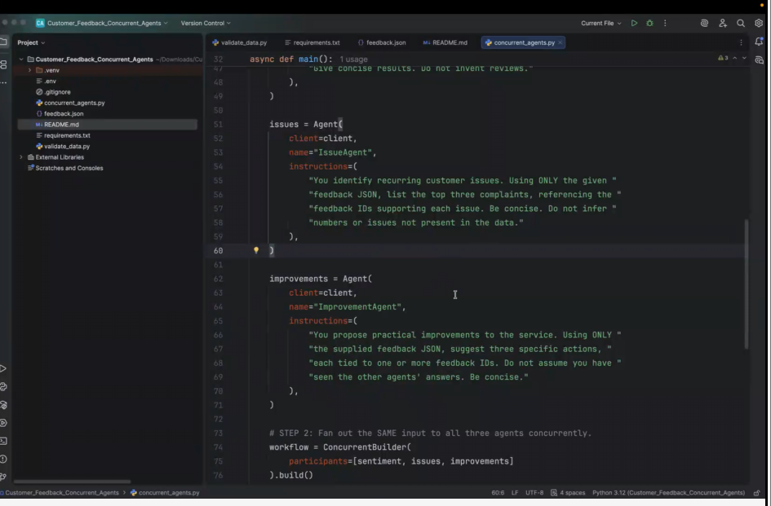
Feedback.json:
[
{
"id": "F001",
"rating": 5,
"area": "Checkout",
"comment": "Checkout was quick and the discount code worked on my first try."
},
{
"id": "F002",
"rating": 2,
"area": "Checkout",
"comment": "Payment failed twice but my bank showed two temporary holds."
},
{
"id": "F003",
"rating": 4,
"area": "Delivery",
"comment": "Parcel arrived a day early and the courier was polite."
},
{
"id": "F004",
"rating": 1,
"area": "Delivery",
"comment": "Delivery arrived four days late without any tracking update."
},
{
"id": "F005",
"rating": 3,
"area": "Search",
"comment": "Search found similar items but filters reset whenever I returned to results."
},
{
"id": "F006",
"rating": 5,
"area": "Support",
"comment": "The support agent fixed my return request within ten minutes."
},
{
"id": "F007",
"rating": 2,
"area": "Support",
"comment": "I waited two days for a response about a damaged item."
},
{
"id": "F008",
"rating": 4,
"area": "Mobile App",
"comment": "App is easy to navigate and saved my preferred address."
},
{
"id": "F009",
"rating": 1,
"area": "Mobile App",
"comment": "App crashed three times when I opened the cart on Android."
},
{
"id": "F010",
"rating": 3,
"area": "Packaging",
"comment": "Product was fine, but the outer box was much bigger than needed."
},
{
"id": "F011",
"rating": 5,
"area": "Product Quality",
"comment": "The headphones sound excellent and match the listing."
},
{
"id": "F012",
"rating": 2,
"area": "Product Quality",
"comment": "Received the wrong colour, despite choosing black at checkout."
},
{
"id": "F013",
"rating": 4,
"area": "Returns",
"comment": "Pickup for my return was arranged the next morning."
},
{
"id": "F014",
"rating": 1,
"area": "Returns",
"comment": "Refund still has not arrived twelve days after my return was accepted."
},
{
"id": "F015",
"rating": 4,
"area": "Delivery",
"comment": "Tracking notifications were accurate throughout delivery."
},
{
"id": "F016",
"rating": 2,
"area": "Checkout",
"comment": "The coupon showed as valid but disappeared on the payment page."
},
{
"id": "F017",
"rating": 3,
"area": "Search",
"comment": "Categories were clear, although sorting by price was inconsistent."
},
{
"id": "F018",
"rating": 5,
"area": "Support",
"comment": "Chat support explained warranty coverage clearly."
},
{
"id": "F019",
"rating": 1,
"area": "Delivery",
"comment": "The delivery window changed twice and no explanation was provided."
},
{
"id": "F020",
"rating": 4,
"area": "Mobile App",
"comment": "The new app layout made reordering much easier."
},
{
"id": "F021",
"rating": 2,
"area": "Returns",
"comment": "Return pickup was missed and I had to contact support again."
},
{
"id": "F022",
"rating": 5,
"area": "Product Quality",
"comment": "The laptop stand feels sturdy and the dimensions were accurate."
},
{
"id": "F023",
"rating": 3,
"area": "Packaging",
"comment": "Packaging protected the item, but too much plastic was used."
},
{
"id": "F024",
"rating": 2,
"area": "Support",
"comment": "The helpdesk sent an automated reply instead of answering my billing question."
}
]
.env file
CODE FOR Concurrent_agents.py:

import asyncio
import json
import os
from pathlib import Path
from time import perf_counter

from dotenv import load_dotenv
from agent_framework import Agent, AgentResponse
from agent_framework.openai import OpenAIChatClient
from agent_framework.orchestrations import ConcurrentBuilder

HERE = Path(__file__).resolve().parent
load_dotenv(HERE / ".env")

def load_feedback():
"""Load the same feedback records for every agent."""
with (HERE / "feedback.json").open(encoding="utf-8") as file:
records = json.load(file)
if not isinstance(records, list) or not records:
raise ValueError("feedback.json must be a non-empty JSON list")
return records

async def main():
if not os.getenv("OPENAI_API_KEY"):
raise SystemExit("Missing OPENAI_API_KEY. Create .env using .env.example")

feedback = load_feedback()
client = OpenAIChatClient(model=os.getenv("OPENAI_MODEL", "gpt-4o-mini"))

# STEP 1: Three independent agents, each with a different responsibility.
sentiment = Agent(
client=client,
name="SentimentAgent",
instructions=(
"You analyze customer sentiment. Using ONLY the given feedback JSON, "
"count positive (ratings 4-5), neutral (rating 3), and negative "
"(ratings 1-2) reviews. Cite 2-3 feedback IDs as examples. "
"Give concise results. Do not invent reviews."
),
)

issues = Agent(
client=client,
name="IssueAgent",
instructions=(
"You identify recurring customer issues. Using ONLY the given "
"feedback JSON, list the top three complaints, referencing the "
"feedback IDs supporting each issue. Be concise. Do not infer "
"numbers or issues not present in the data."
),
)

improvements = Agent(
client=client,
name="ImprovementAgent",
instructions=(
"You propose practical improvements to the service. Using ONLY "
"the supplied feedback JSON, suggest three specific actions, "
"each tied to one or more feedback IDs. Do not assume you have "
"seen the other agents' answers. Be concise."
),
)

# STEP 2: Fan out the SAME input to all three agents concurrently.
workflow = ConcurrentBuilder(
participants=[sentiment, issues, improvements]
).build()

# STEP 3: Run once, collect the three independent results (fan in).
prompt = (
"Analyze these fictional customer feedback records. "
"Use the assigned role's instructions.\n\n"
+ json.dumps(feedback, ensure_ascii=False, indent=2)
)

print(f"Analyzing {len(feedback)} customer reviews with 3 concurrent agents...\n")
started = perf_counter()
result = await workflow.run(prompt)

# Default aggregation returns one AgentResponse containing the agent messages.
for output in result.get_outputs():
if isinstance(output, AgentResponse):
for message in output.messages:
print(f"\n{'=' * 56}")
print(f"{message.author_name or 'Agent'}")
print("=" * 56)
print(message.text or "(No text returned)")

print(f"\nCompleted in {perf_counter() - started:.1f} seconds")

if __name__ == "__main__":
asyncio.run(main())
changes made in code for using groq api:
OUTPUT :
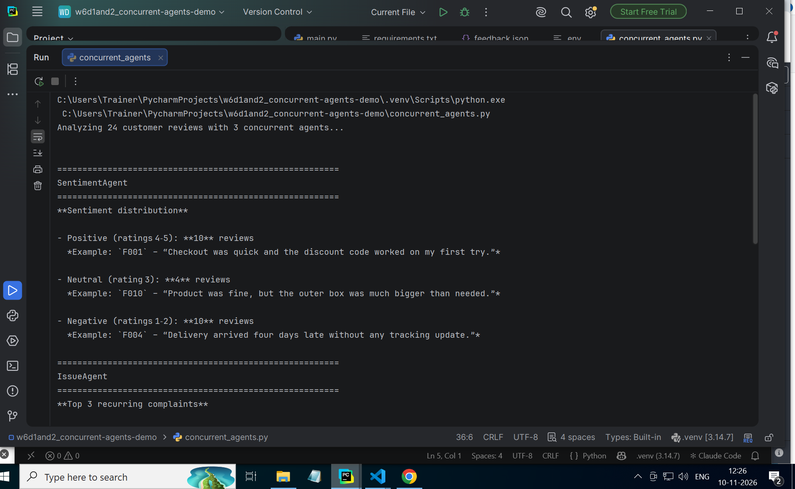
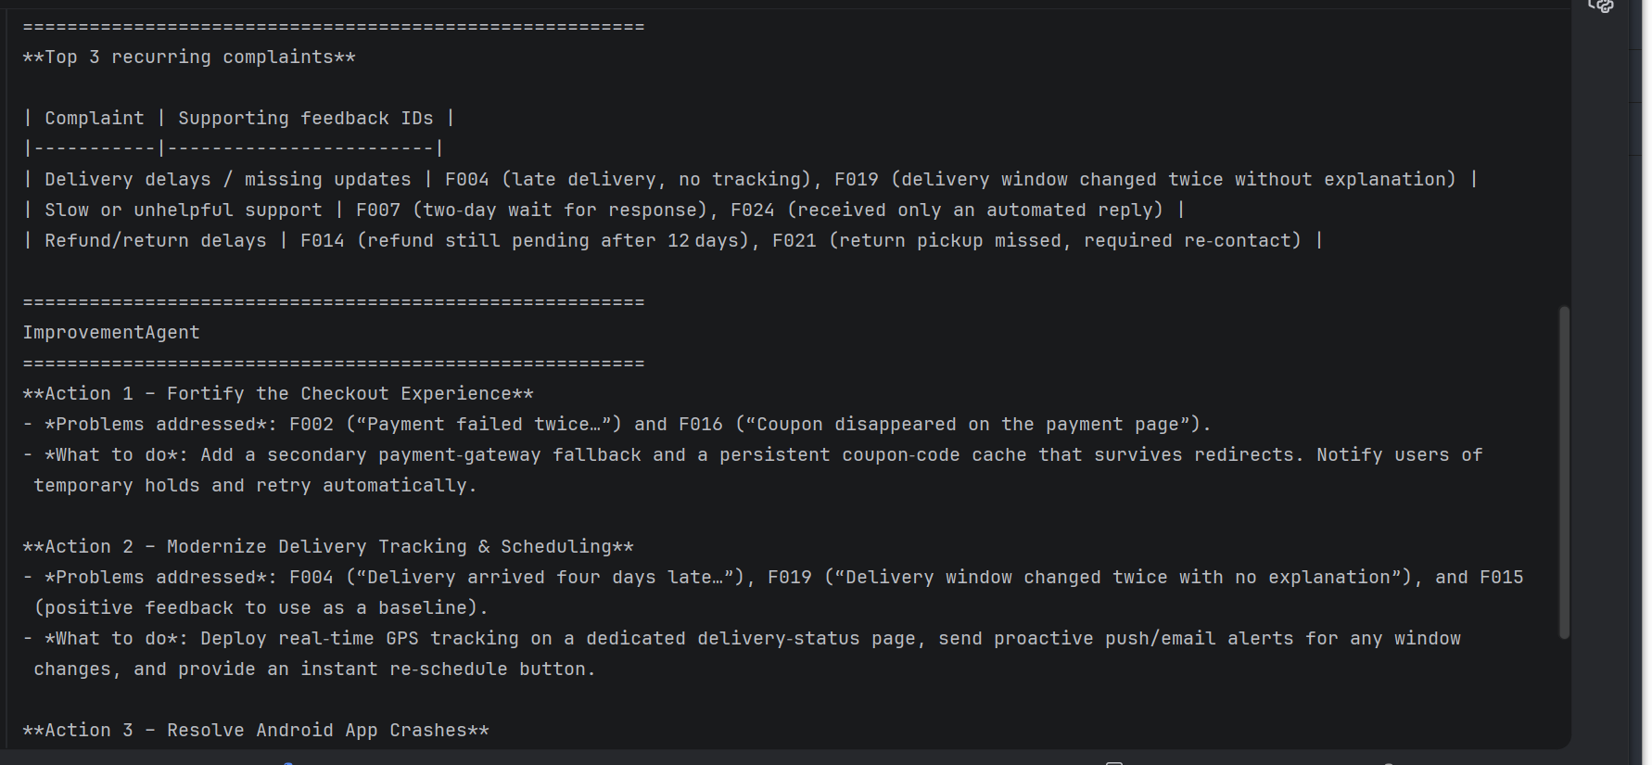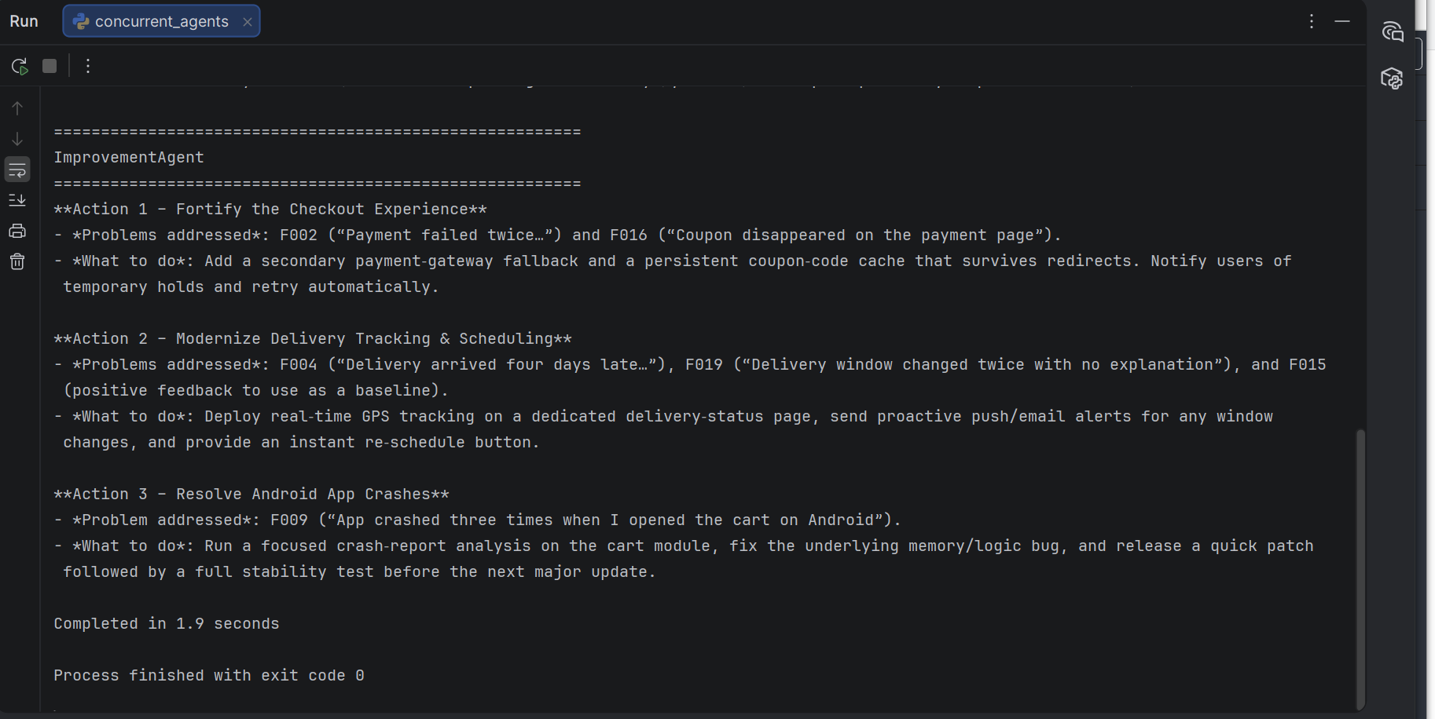
OUTPUT IN TEXT:
C:\Users\Trainer\PycharmProjects\w6d1and2_concurrent-agents-demo\.venv\Scripts\python.exe C:\Users\Trainer\PycharmProjects\w6d1and2_concurrent-agents-demo\concurrent_agents.py
Analyzing 24 customer reviews with 3 concurrent agents...

========================================================
SentimentAgent
========================================================
**Sentiment distribution**

- Positive (ratings 4‑5): **10** reviews
*Example: `F001` – “Checkout was quick and the discount code worked on my first try.”*

- Neutral (rating 3): **4** reviews
*Example: `F010` – “Product was fine, but the outer box was much bigger than needed.”*

- Negative (ratings 1‑2): **10** reviews
*Example: `F004` – “Delivery arrived four days late without any tracking update.”*

========================================================
IssueAgent
========================================================
**Top 3 recurring complaints**

| Complaint | Supporting feedback IDs |
|-----------|------------------------|
| Delivery delays / missing updates | F004 (late delivery, no tracking), F019 (delivery window changed twice without explanation) |
| Slow or unhelpful support | F007 (two‑day wait for response), F024 (received only an automated reply) |
| Refund/return delays | F014 (refund still pending after 12 days), F021 (return pickup missed, required re‑contact) |

========================================================
ImprovementAgent
========================================================
**Action 1 – Fortify the Checkout Experience**
- *Problems addressed*: F002 (“Payment failed twice…”) and F016 (“Coupon disappeared on the payment page”).
- *What to do*: Add a secondary payment‑gateway fallback and a persistent coupon‑code cache that survives redirects. Notify users of temporary holds and retry automatically.

**Action 2 – Modernize Delivery Tracking & Scheduling**
- *Problems addressed*: F004 (“Delivery arrived four days late…”), F019 (“Delivery window changed twice with no explanation”), and F015 (positive feedback to use as a baseline).
- *What to do*: Deploy real‑time GPS tracking on a dedicated delivery‑status page, send proactive push/email alerts for any window changes, and provide an instant re‑schedule button.

**Action 3 – Resolve Android App Crashes**
- *Problem addressed*: F009 (“App crashed three times when I opened the cart on Android”).
- *What to do*: Run a focused crash‑report analysis on the cart module, fix the underlying memory/logic bug, and release a quick patch followed by a full stability test before the next major update.

Completed in 1.9 seconds

Process finished with exit code 0

